Customer Code | N/A | Customer Spec No. | N/A
Production Site | Telford | EC Code | 4667

 | 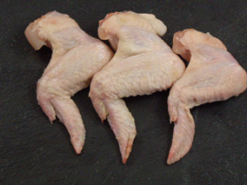 | 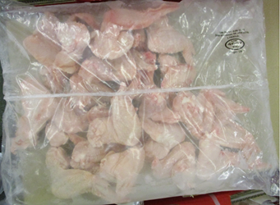

Raw Material | Grade A Three Joint Wings  Product is a mixture of A & B grade wings. Wings should be 3 joint.  NO SINGLE JOINT WINGS | Piece Weight | N/A
 |  | Piece Dimensions | N/A
Piece Count | N/A | Pack Weight | 12kg (4x 3kg bags) | Fixed
Ingredient | Supplier Code | GP Code | Addition
- | - | - | -

PRIMARY PACKAGING
Packaging | Supplier Code | GP Code | Tare
VFFS Clear ULMA Film | N/A | 83101441
 |  | Bizerba Tare

SECONDARY PACKAGING
Packaging | Supplier Code | GP Code | Tare
Brown Box 515 Lid x 15kg | GWL103038 | 83010307 | 191.60g
Brown Box 516 Base x 15kg | GWL103039 | 83010308 | 185.10g
Case End Label | ANFA10 | 82020901 | 1.26g
EC Label | N/A | 82011003 | 0.56g
 |  | Case Tare | 378.02g

TERTIARY PACKAGING
Packaging | Supplier Code | GP Code | Tare
White Pallet | WP | N/A | 22kg
IBIS’ Machine Pallet Wrap 17mu | N/A | 83100702 | 1kg
DCT Pallet Label | ANFA10 | 82020901 | 1.26g
 |  | Pallet Tare | Full pallet approx. 38.1kg

OUTER AND PALLET CONFIGURATION
Units per outer | 4 | Outers per layer | 5 | Outers per Pallet | 40

PRODUCT LIFE
Product Life (Days) | K+548 | Depot Life (Days) | D+365
Agreed Exceptions | -

QUALITY STANDARDS | CODING INFORMATION
Refer to product QAS | Refer to Fusion Data Sheet

PACK CODING | CASE END LABEL
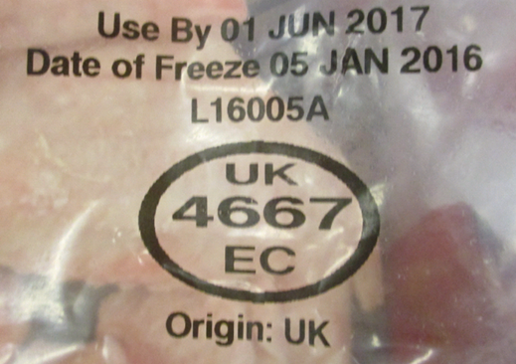 | 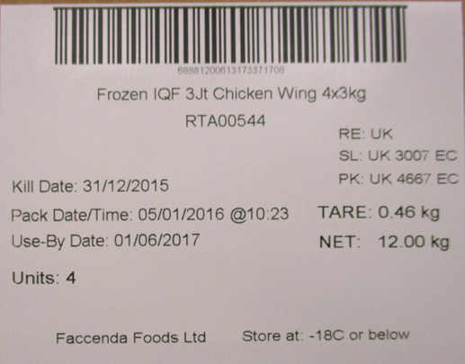

OUTER CONFIGURATION | PALLET CONFIGURATION
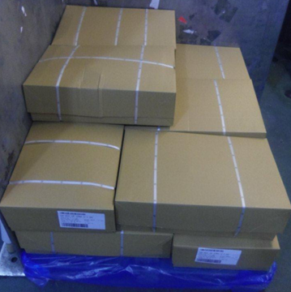 | 